**Spring Potential Energy**

* Analogous
* Example: block of energy
  + Atoms move have KPE (Kinetic Potential Energy)
  + Springs flex have SPE (Spring Potential Energy)
  + Define **u** : total KE of all atoms plus total SPE of all bonds (energy that is contained in the unit of the system)
* Example: Gas in the classroom
  + One atom:
    - KE = 2 e.u. (energy units)
    - SPE = 0 (Gas → no bonds)
    - 1023 atoms in gas
    - Then U (Gas) = 2 * 1023 energy units

**Heat**

* Transfer of internal energy U due to a temperature difference
* Hot → Cold but NOT VICE VERSA (internal energy flows from a hot object into a colder object)
* Heat is not energy contained by a system
* Heat: flowing internal energy

**Heat (U) Transfer Mechanism**

* Conduction: molecular or electron collisions)

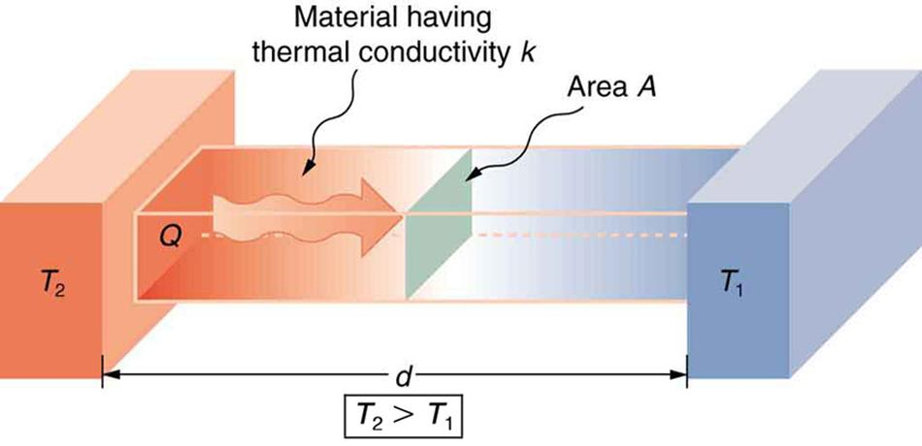

* Convection: flow of matter

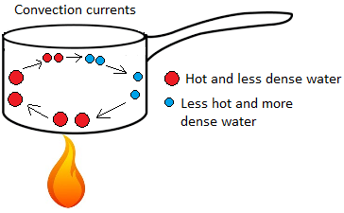

* Energy and molecules are flowing

Radiation: electromagnetic (example: waves)

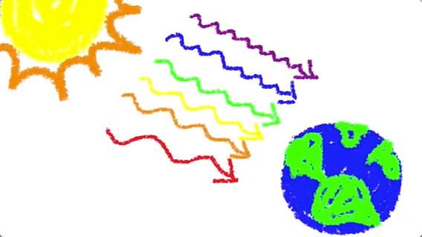

* Not testing on conceptual parts

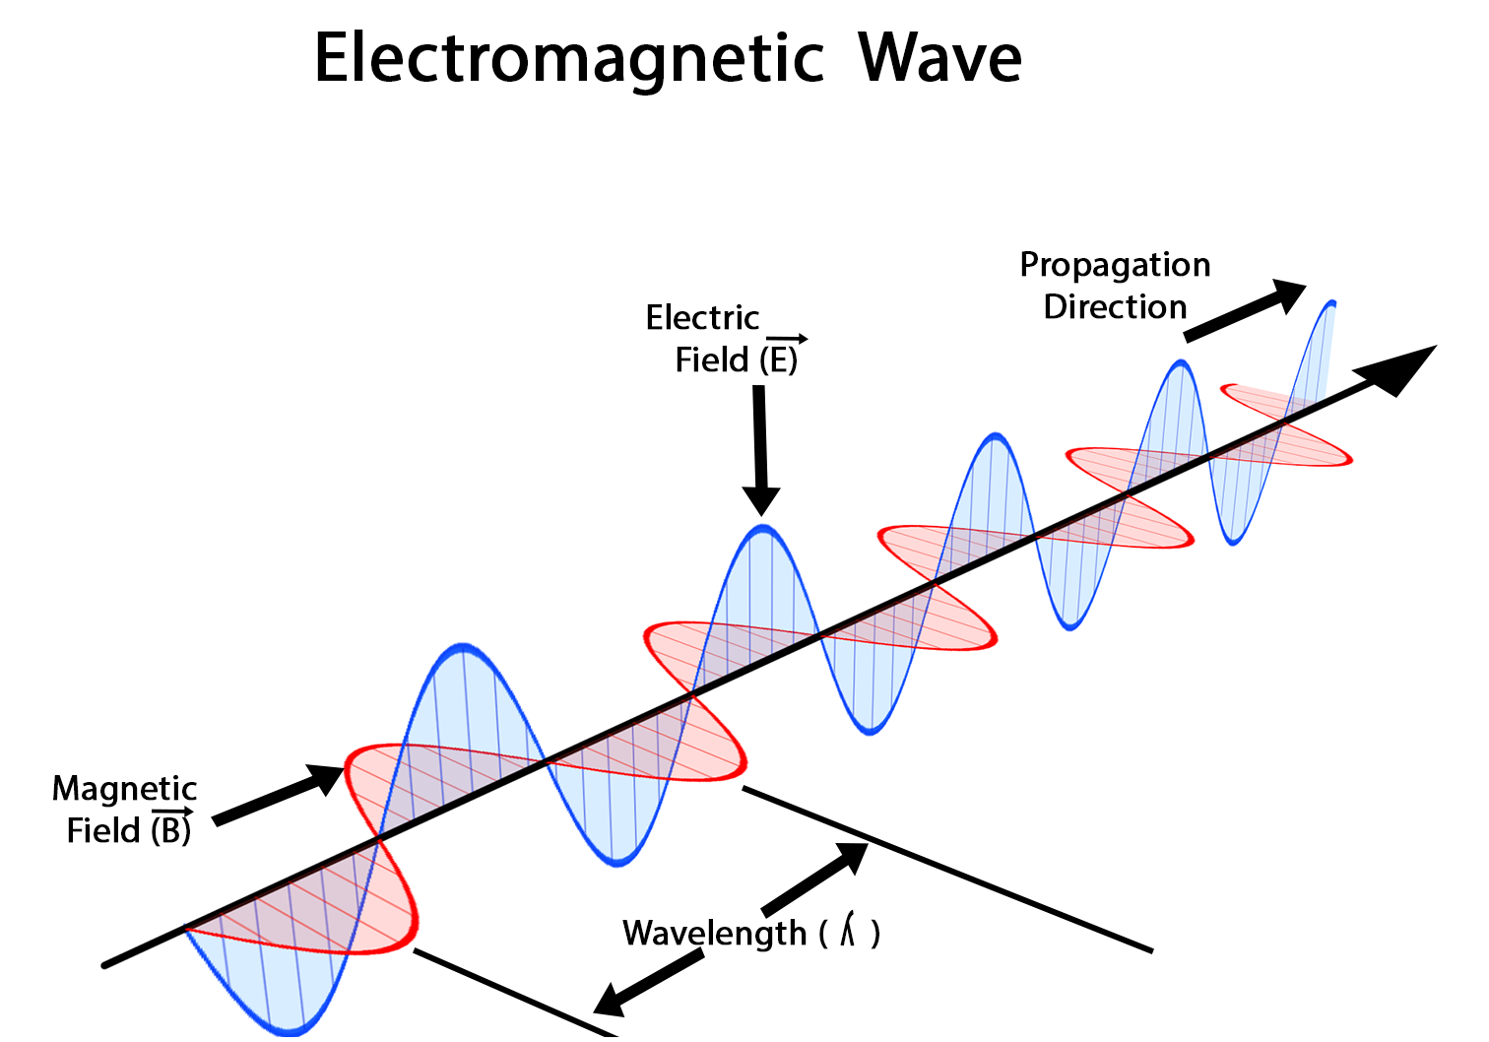

* Oscillating & traveling electric force pattern
* Mass ←→ Gravity Force
* Charge ← → Electric Force (F)
* E.M waves carry energy
  + Can travel through a vacuum (v = c)
  + **λ** : wavelength (Lambda)
  + C = 3.0 * 108
  + C = 186, 000 miles/second
  + Both equations are valid for **λ**

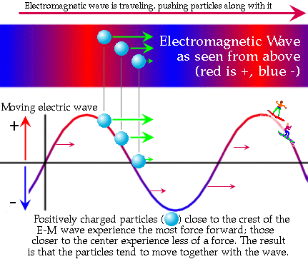

* **λ =** wavelength (in meters)
* Missing two other formulas
* Find the period of a visable light wave with wavelength of 500 nm
* T = 1/f & we need f
* (C [Electromagnetic wave] = **λf** => f = c/**λ**)
* F = = 6 * 1014 cycles/seconds
* T = = 1.67 * 10-15 seconds

